As your Medicare Administrative Contractor (MAC), National Government Services is dedicated to working with providers in the rural areas we serve. Our goal is to keep you informed about changes to Medicare and the training opportunities available to you.
National Government Services Part A & B News
- 2021 Medicare Participating Physicians Directory
- Appropriate Usage of Modifier 99
- Article Updates for February and March 2021
- COVID-19 Vaccine and/or Monoclonal Antibodies in Rural Health Clinics and Federally Qualified Health Centers
- Medicare Advantage Plan Beneficiaries Receiving the COVID-19 Vaccine and Monoclonal Antibody
- National Government Services Part B Medical Review Newsletter - March 2021
- Practitioners: Are You Ordering Lower Limb Orthoses for Your Patients?
- Real Time Claim Status and Response (276/277) Coming for Part B
- Service Specific Post Payment Review of Botulinum Injection, onabotulinumtoxina, 1 Unit – CPT J0585 (for J6 Part B Providers)
- Service Specific Post Payment Review of Fluoroscopic Guidance for Needle Placement - CPT 77002 (for J6 Part B Providers)
- The Medicare Part A and Part B Billing for the COVID-19 Vaccine and Monoclonal Antibody article has been updated to include the Janssen (Johnson & Johnson) vaccine and administration information.
- April 2021 EDI Front-End Quarterly Release: New and Modified Edits
- Save the Date: National Government Services Spring 2021 Virtual Conference
- Prescription Drug Management
- EDI Monthly Bulletin for March 2021
- About Appeals
- Provider Enrollment: Change in Practice Location
- Billing and Coding for Tempus Next Generation Sequencing Panel
- Billing Tip for COVID-19 Vaccine as a Mass Immunizer Roster Biller - Use the Taxonomy Code
- LCD and Article Updates for April 2021
- Local Coverage Determination L33626: Psychiatric Partial Hospitalization Programs
- New Version of PC-ACE: April 2021
- Service Specific Post Payment Review of Computed Tomography, Abdomen and Pelvis with Contrast Material(s) - CPT 74177 (Jurisdiction 6)
- Updated Billing Requirements for Home Infusion Therapy (HIT) Services on or After 1/1/2021
Centers for Medicare & Medicaid Services News
- MLN Connects® for Thursday, March 4, 2021
- MLN Connects® Special Edition for Wednesday, March 10, 2021
- MLN Connects® for Thursday, March 11, 2021
- MLN Connects® Special Edition for Monday, March 15, 2021
- MLN Connects® for Thursday, March 18, 2021
- MLN Connects® for Thursday, March 25, 2021
Reminders
- April 2021 Release "Dark Days" for the Common Working File Hosts
- Amending Medical Records
- April 2021 EDI Front-End Quarterly Release: New and Modified Edits
- From the Desk of the MAC Medical Directors: Caring for Medicare Patients is a Partnership
- April 2021 Release "Dark Days" for the Common Working File Hosts
- April 2021 EDI Front-End Quarterly Release: New and Modified Edits
April Medicare Monthly Review Issue 2021-04 Is Now Available
The April 2021 issue of the Medicare Monthly Review (2021-04) has been posted and is now available on our website. This tool will provide you with all Part A, Part B and Home Health and Hospice communications that NGS has sent, as well as CMS’ Weekly Provider eNews articles. Take a look to be sure you did not miss something important!
New Consolidated Home Page is Coming Soon!
NGSConnex and NGSMedicare will soon be uniting to become your new consolidated homepage – NGSMedicare.com. Why are we making these changes? We have listened and gained invaluable insight from you so now it’s time to put your feedback into action! Watch this video to prepare and learn more about these exciting changes being released soon!

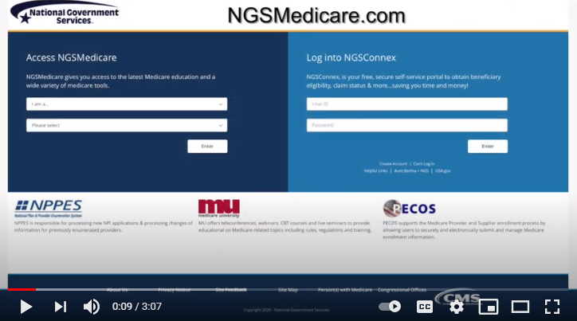

Registration is Open for the NGS May 2021 Virtual Conference
The National Government Services Provider Outreach and Education Team is holding our latest bi-annual virtual conference on Tuesday, 5/11/2021 and Wednesday, 5/12/2021. This two full-day virtual conference will offer a variety of Part A, Part B, FQHC and self-service sessions. There are no associated charges for this virtual conference and you may register for as many sessions as you’d like.
Sessions will begin with a presentation, then we will address your questions. This is your opportunity to hear about the latest Medicare education from our POE team and ask your questions immediately following.
To register, select the link(s) below or visit Webinars, Teleconferences & Events under the Education tab and scroll down to 5/11/2021 and 5/12/2021 to view and register for sessions. Seating is limited so register today!
Please note: All times listed are ET.
Date | Time | Option 1 | Option 2 | Option 3
5/11/2021 | 8:30 ‒ 9:45 a.m. | Part A & FQHC  The “Ins” and “Outs” of the Appeals Process | Part B  Medicare Physicians Fee Schedule Database | All  What is NGSConnex?
5/11/2021 | 10:00 ‒ 11:15 a.m. | Part A & FQHC  Control Your Finances by Understanding the Medicare Overpayment Process | Part B  Medical Necessity and the Advance Beneficiary Notice | All  Medicare University
5/11/2021 | 11:30 ‒ 12:45 p.m. | Part A & FQHC  Preparing and Submitting Medicare Secondary Payer Claims in the Fiscal Intermediary Standard System Direct Data Entry | Part B  Critical Care Services | Part A & FQHC  Explanation of Part A Top 10 Edit Reports
5/11/2021 | 1:00 ‒ 2:15 p.m. | Part A & FQHC  Hospital Outpatient Opioid Treatment Program Services Overview | Part B  Surgery Modifiers | All  Provider Enrollment 101
5/11/2021 | 2:30 ‒ 3:45 p.m. | Part A & FQHC  COVID-19 Vaccine Administration and Monoclonal Antibody Infusion Billing for Part A Providers | All  Medicare Audit Contractors | All  Electronic Attachments from the Beginning
5/11/2021 | 4:00 ‒ 5:15 p.m. | Part A & FQHC  What Rural Health Clinics and Federally Qualified Health Centers Need to Know for 2021 | Part B  Five Why’s for Incident To | N/A
5/12/2021 | 8:30 ‒ 9:45 a.m. | Part A & FQHC  Skilled Nursing Facility Consolidated Billing- Who is Responsible for Billing Medicare? | Part B  Submitting Medical Documentation Electronically | Part B  Explanation of Part B Top 10 Edit Reports
5/12/2021 | 10:00 ‒ 11:15 a.m. | All  Prior Authorization Program for Certain Hospital Outpatient Department Services | All  Fraud Prevention and Detection | Part B  Medical Review Focus
5/12/2021 | 11:30 ‒ 12:45 p.m. | Part A & FQHC  Increase Your Cash Flow by Efficiently Verifying Medicare Eligibility | Part B  Working with NGS to Reduce Provider Burden | N/A
5/12/2021 | 1:00 ‒ 2:15 p.m. | Part A & FQHC  A Peek Inside the Three-Day Payment Window for Acute Care Hospitals | Part B  2021 E/M Changes Let’s Chat: Answering Your Questions  *No CEUs are available for this open forum session | N/A
5/12/2021 | 2:30 ‒ 3:45 p.m. | Part A & FQHC  Introduction to NCDs and LCDs: Learn What They Are and How to Find Them | Part B  National Correct Coding Initiative and the Medically Unlikely Edits | N/A
5/12/2021 | 4:00 ‒ 5:15 p.m. | Part A & FQHC  Physicians and Allowed Practitioners Referring to and Monitoring Patients in Home Health and Hospice | Part B  Part B Ask-the-Contractor: 2021 Virtual Conference Open Question and Answer Forum  *No CEUs are available for this open forum session | N/A

